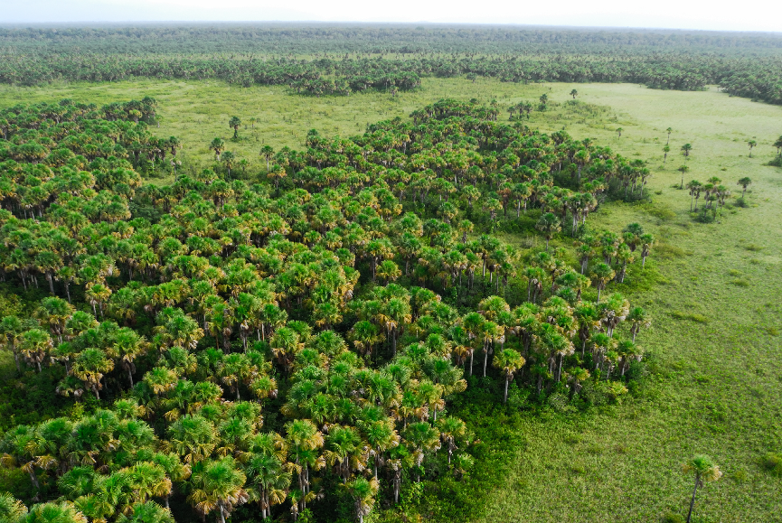
(Date of submission XX)
Reporting period (XX)
Grant
(Reference number)
Technical report n° XX
© O. Tostain

SUMMARY:
- Main achievements:
(Describe here the main achievements in comparison with the results and activities planned)

- New additional activities:
(Describe here the new and additional activities you may have implemented (put N/A if it is not the case)

- Main challenges:
(Describe here the issues, difficulties you may have encountered in the implementation of your activities)

- ESMS issues encountered and mitigation response:
(Describe here the social and environmental issues you may have faced and the solution you implemented for mitigating them)

- Lessons learned:
(Describe here the main lessons learned from the implementation of the activities)

- Best practices/innovative approach:
(Describe here if you have deployed best practices or innovative approach)

- Success story:
(Describe here if your project has induced specific positive impact(s)

Self-assessment (please tick the relevant box and delete the others):
☐ Project on track – satisfactory implementation of all activities
☐ Project delayed – issues impacted the timely implementation of activities
☐ Project at risk – major issues impacted the implementation of activities and jeopardized the project

Table of Contents
SUMMARY: 1
Self-assessment (please tick the relevant box and delete the others): 1
I Context of the project – Evolution 3
II Results and activities implementation 3
II.1 Result 1 – Title 3
II.1.1 Activity 1 - Title 3
II.1.1 Activity 2 - Title 4
III Logical Framework 5
III.1 Main facts and figures: 5
IV ESMS report 5
IV.1 Mitigation measures 5
IV.2 Grievance management 0
IV.3 Serious incident(s) 0
ANNEXES 2
Annex 1: Deliverables copy 2
Annex 2: Sources of verification copies 2
Annex 3: Pictures of results/ activities with credits and legend 2
Annex 4 : Copy of Press articles/Social Media activities 2

I Context of the project – Evolution

(Describe here any change in the context of your project in comparison with what was described in your technical proposal)

II Results and activities implementation

Please report on the implementation of the results and activities as per your approved log frame. Add as many ‘Results’ and relevant ‘Activities’ as needed.

II.1 Result 1 – Title
Self-assessment (please tick the relevant box and delete the others):
☐ Result on track – satisfactory implementation of all activities
☐ Result delayed – issues impacted the timely implementation of activities
☐ Result at risk – major issues impacted the implementation of activities and jeopardized the implementation of the result

(Describe here the overall implementation of your Result)

Activity 1 - Title

(Describe here the overall implementation of the activity)

Activity 2 - Title

(Describe here the overall implementation of the activity)

II.1 Result 2 – Title
Self-assessment (please tick the relevant box and delete the others):
☐ Result on track – satisfactory implementation of all activities
☐ Result delayed – issues impacted the timely implementation of activities
☐ Result at risk – major issues impacted the implementation of activities and jeopardized the implementation of the result

(Describe here the overall implementation of your Result)

Activity 1 - Title

(Describe here the overall implementation of the activity)

Add as many ‘Results’ and relevant ‘Activities’ as needed.

Add a map with location of activities implemented during the reporting period

II.1 Cross-cutting Result – Communication, visibility and branding activities
Self-assessment (please tick the relevant box and delete the others):
☐ Result on track – satisfactory implementation of all activities
☐ Result delayed – issues impacted the timely implementation of activities
☐ Result at risk – major issues impacted the implementation of activities and jeopardized the implementation of the result

- Use this section to report on compliance with the BIOPAMA grantee communication guidelines. Please add links to relevant webpages/reports etc. in this section. Please use Annex 3 for adding any pictures, photos, reports etc.
- Use the next section to report on Results and Activities (according to your agreed log frame) to report on communication activities that were agreed in your project design. Please add links to relevant webpages/reports etc. in this section. Please use Annex 3 for adding any pictures, photos, reports etc.

In the table below, please list the activities planned for the next reporting period.

Activity planned | Month in which the activity is planned

III Logical Framework
Please update and complete your logical framework on-line. Please do not forget to update your BIOPAMA AC indicators, this is compulsory for the validation of your technical report.

III.1 Main facts and figures:

BIOPAMA AC indicators | Target value | Value reached | Source of verification
Deliverables

IV ESMS report

IV.1 Mitigation measures
Please describe in the table below the activities you have implemented in order to mitigate the environmental and social risks.

(add N/A and delete the tables below if not applicable as no ESMS issues or risk has emerged. Fake/incomplete reporting may have contractual consequences)

Disclosure
Template 2: ESMP Monitoring
Period covered by the report:
ESMS Standards | Describe the progress of implementing the required tools (Indigenous Peoples Plan, Process Framework etc.):
Social & Environmental Impacts | Mitigation measures | Color coding | Describe status of completion, suggest solutions where problems are encountered |  | Early judgement: Does this measure seem effective?
New ESMS risks that have emerged
Other ESMS provisions | Describe status of completion and evidence |  |  |  | Outstanding action and timing
Disclosure
Grievance Mechanism
Gender Mainstreaming
Stakeholder Engagement
TO BE COMPLETED BY Lead organisation of the project |  |  |  | Date/Name of reviewer:
ESMP monitoring - main findings: |  |  |  | Status ESMP  ☐ on schedule  ☐ slightly delayed  ☐ major delays/issues

Template 3: Plan for Monitoring Effectiveness of ESMP TO BE COMPLETED BY the Lead organisation of the project
Mitigation measures | Indicators proving effectiveness of avoidance or reducing impacts | Baseline | Monitoring methodology | Target (mid-term) | Target (end of project)
A | B | C | D | E | F
New ESMS risks that have emerged

IV.2 Grievance management
(add N/A and delete the content below if not applicable)
Please list below the grievance you have received and how you have treated and solved them. Please put as well in the annex the grievance form submitted to you.

Grievance | Organisation/individual | Measures | Status ( fixed/on-going/not solved)
X | X | X

IV.3 Serious incident(s)
(add N/A and delete the content below if not applicable)
Please recall here the serious incident that may have happened during the reporting period. All serious incidents must be reported to the BIOPAMA AC Regional team( use the relevant mailing list for your region) and Secretariat within 48 hours of the incident occurring, using the template provided below.

A serious incident is an unplanned or uncontrolled event that has an adverse effect on project personnel and workers, community members or on the environment within the project’s area of influence, as well as events that have adverse effects on the project or that give rise to liabilities or reputational risks that could jeopardize achievement of the project’s objectives.

Serious Incident Report
General Information
Project name, country, region
Executing Agency
Person and agency submitting the information
Organizations, agencies and/or companies involved in the incident
Details of the people affected, status (e.g. if they are working as rangers, volunteers, etc.), names, ages, gender. Details of the community or communities involved
Details of the Incident
Date and time the Incident occurred
Location
Type of Incident | Fatalities, serious injuries and accidents at work ☐
 | Fatalities, serious injuries and accidents affecting local communities and others ☐
 | Violations of human rights or accusation of human rights violations, incl. sexual and gender-based violence and harmful child labor ☐
 | Forced Eviction ☐
 | Conflicts, disputes and disturbances leading to loss of life, violence or the risk of violence☐
 | Environmental incidents ☐
Detailed chronological description of the Incident and its circumstances (if possible with photos)
Root Cause Analysis
Detailed description of key causational factors (internal and external), potential management failings and identification of absent/ inadequate/ failed/ unused management and control measures
(e.g., non-compliances with ESMS standards or measures)
Specification of relevant roles and responsibilities of the agencies, authorities and others involved
Reaction to the incidents by the victims, involved families or communities as well as local/national/international media
Agency or agencies responsible for investigation of the case. What is the scope of the investigation? Does this include a root cause analysis?
Response and Corrective Actions
Description of the response (if available) and agencies involved.
Description of any corrective actions, plans or next steps to prevent the incident from recurring or follow up to close the case or proceed with further investigations (include action plan with responsibilities and schedule)
Incident Report Approval
 | Position | Name | Date
Prepared by
Approved by (BIOPAMA Senior Management)

ANNEXES

Annex 1: Deliverables copy (report/minutes of meetings).
Please organise the info as per your Logframe per results/ activities

Annexe 2: Activities pictures with credits and legend/links.
Please organise the info as per your Logframe per results/ activities

Annex 3: Supporting documents for the communication, visibility and branding activities (e.g. copy of Press articles/ Print screen of Social Media activities).
Please add document-resolution photos, etc. Do not insert original high-quality pictures but keep them in your records for potential other uses.

Please organise the info as per your Logframe per results/ activities.

Column A and B are copied from the ESMP.
Identify one indicator for each mitigation measure. Use the same numbering as for mitigation measures as in Table 1 and use corresponding number for indicators; e.g., measure 1 (M1) would be monitored by indicator 1 (Ind1).
biopama.ac.info.caribbean@iucn.org ; biopama.ac.info.pacific@iucn.org ; biopama.ac.info.wca@iucn.org ; biopama.ac.info.esa@iucn.org
BiopamaGrantSecretariat@iucn.org

